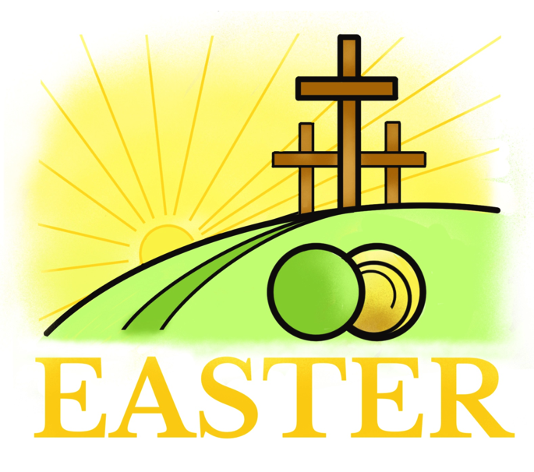
Alleluia! Christ is risen.
He is risen indeed. Alleluia!

HANLEY TEAM MINISTRY W/C 28 April, 2024

FIFTH SUNDAY OF EASTER

Sun. Team Eucharist 09.30 Christ Church
11.00 Holy Trinity

Tue. Eucharist * 10.00 St. Matthew’s
Wed. Eucharist * 11.00 St. Luke’s
Thu. Morning Prayer 10.00 Christ Church

- Subject to availability of clergy, some of these may be
Communion by Extension services in the short term.

COLLECT
POST COMMUNION SENTENCE

Eternal God,
whose Son Jesus Christ is the way, the truth, and the life:
grant us to walk in his way,
to rejoice in his truth,
and to share his risen life;
who is alive and reigns, now and for ever.

Risen Christ,
your wounds declare your love for the world
and the wonder of your risen life:
give us compassion and courage
to risk ourselves for those we serve,
to the glory of God the Father.

HYMNS

MP | CHRIST CHURCH | AM / MP | HOLY TRINITY
449 | Love divine, all loves excelling | AM 126 | The King of love my shepherd is
175 | Gloria | Gloria | Appleford
411 | Let there be love | AM 365 | God is love (Tune: Hyfrydol)
397 | King of glory, King of peace | MP 792 | You are the vine
581 | River, wash over me | MP 1 | A new commandment
315 | I will sing the wondrous story | AM 131 | Love divine (Tune: Love Divine)

Team Rector: Rev. Phillip Jones (01782) 922540
revphillip.e.jones@outlook.com
Strategic Missioner: Rev. Mike Bridgewater 07488233118
revmikebridgewater@gmail.com
Assistant Minister: Rev. Gill Shilkoff 07525668262
gillshilkoff@btinternet.com
Pioneer Missioner: Rev.Catherine Matlock
07944728782 Catherine.matlock@lichfield.anglican.org
READINGS

ACTS 8: 26-40
²⁶ An angel of the Lord said to Philip, ‘Get up and go towards the south to the road that goes down from Jerusalem to Gaza.’ (This is a wilderness road.)
²⁷ So he got up and went. Now there was an Ethiopian eunuch, a court official of the Candace, queen of the Ethiopians, in charge of her entire treasury. He had come to Jerusalem to worship ²⁸ and was returning home; seated in his chariot, he was reading the prophet Isaiah.
²⁹ Then the Spirit said to Philip, ‘Go over to this chariot and join it.’
³⁰ So Philip ran up to it and heard him reading the prophet Isaiah. He asked, ‘Do you understand what you are reading?’
³¹ He replied, ‘How can I, unless someone guides me?’ And he invited Philip to get in and sit beside him.
³² Now the passage of the scripture that he was reading was this:
‘Like a sheep he was led to the slaughter,
and like a lamb silent before its shearer,
so he does not open his mouth.
³³ In his humiliation justice was denied him.
Who can describe his generation?
For his life is taken away from the earth.’
³⁴ The eunuch asked Philip, ‘About whom, may I ask you, does the prophet say this, about himself or about someone else?’
³⁵ Then Philip began to speak, and starting with this scripture, he proclaimed to him the good news about Jesus.
³⁶ As they were going along the road, they came to some water; and the eunuch said, ‘Look, here is water! What is to prevent me from being baptized?’
³⁸ He commanded the chariot to stop, and both of them, Philip and the eunuch, went down into the water, and Philip baptized him.
³⁹ When they came up out of the water, the Spirit of the Lord snatched Philip away; the eunuch saw him no more, and went on his way rejoicing.
⁴⁰ But Philip found himself at Azotus, and as he was passing through the region, he proclaimed the good news to all the towns until he came to Caesarea.

1 JOHN 4 :7–21
⁷ Dear friends, let us love one another, because love is from God; everyone who loves is born of God and knows God.
⁸ Whoever does not love does not know God, for God is love.
⁹ God’s love was revealed among us in this way: God sent his only Son into the world so that we might live through him.
¹⁰ In this is love, not that we loved God but that he loved us and sent his Son to be the atoning sacrifice for our sins.
¹¹ Dear friends, since God loved us so much, we also ought to love one another.
¹² No one has ever seen God; if we love one another, God lives in us, and his love is perfected in us.
¹³ By this we know that we abide in him and he in us, because he has given us of his Spirit.
¹⁴ And we have seen and do testify that the Father has sent his Son as the Saviour of the world.
¹⁵ God abides in those who confess that Jesus is the Son of God, and they abide in God.
¹⁶ So we have known and believe the love that God has for us. God is love, and those who abide in love abide in God, and God abides in them.
¹⁷ Love has been perfected among us in this: that we may have boldness on the day of judgement, because as he is, so are we in this world.
¹⁸ There is no fear in love, but perfect love casts out fear; for fear has to do with punishment, and whoever fears has not reached perfection in love.
¹⁹ We love because he first loved us.
²⁰ Those who say, ‘I love God’, and hate their brothers or sisters, are liars; for those who do not love a brother or sister whom they have seen, cannot love God whom they have not seen.
²¹ The commandment we have from him is this: those who love God must love their brothers and sisters also.

John 15: 1-8

1 Jesus said: ‘I am the true vine, and my Father is the vine-grower.

² He removes every branch in me that bears no fruit. Every branch that bears fruit he prunes to make it bear more fruit.

³ You have already been cleansed by the word that I have spoken to you.

⁴ Abide in me as I abide in you. Just as the branch cannot bear fruit by itself unless it abides in the vine, neither can you unless you abide in me.

⁵ I am the vine, you are the branches. Those who abide in me and I in them bear much fruit, because apart from me you can do nothing.

⁶ Whoever does not abide in me is thrown away like a branch and withers; such branches are gathered, thrown into the fire, and burned.

⁷ If you abide in me, and my words abide in you, ask for whatever you wish, and it will be done for you.

⁸ My Father is glorified by this, that you bear much fruit and become my disciples.’

MAY

Thu 09 ASCENSION DAY EUCHARIST 7.30 p.m. St. Mark’s
Fri 10 Civic Breakfast 7.30 a.m. King’s Hall
Sun 12 Big Culture Event 12.00-4.00 St. Mark’s
Mon 13 Gathering & Games 2.00 Geek Retreat
Birches Head Res. Assoc. 7.15 St. Matthew’s
Tue 14 St. Matthew’s ADCM 11.00 St. Matthew’s
‘Choc N’ Chat’ 2.00 St. Mark’s
Holy Trinity ADCM 7.30 Holy Trinity
Thu 16 Christ Church ADCM 11.00 Christ Church
Sat 18 Red Cross Coffee Morning 11.00 Holy Trinity
Sun 19 Evensong 4.00 Holy Trinity
Sat 25 Coffee Morning 10.00 St. Matthew’s
Thu 30 Messy Church 3.30 St. Matthew’s
Northwood Res. Assoc. 7.00 Hope Church

A Baby & Toddler Group meets 1.00 p.m. at St. Luke’s Church on Wednesdays during term-time

